**ADDITIONANAL MATERIAL FOR ROBUST PROPERTY-STRUCUTURE LINKAGE FOR POLYMER COMPOSITES**

## **Statement of Significance**

This research is significant in that it presents a novel approach to efficiently modeling the effective properties of fiber composites from microstructure images. The results of this model compare favorably with established models for property prediction. The workflow is documented and easily adaptable to the creation of models on other materials systems. Creation of these new models from this workflow would allow an increase in the rate of material deployment by allowing the rapid exploration of large design spaces in material structures. This rapid exploration with allow for the streamlining of the materials selection process.

## **Graphical Abstract**

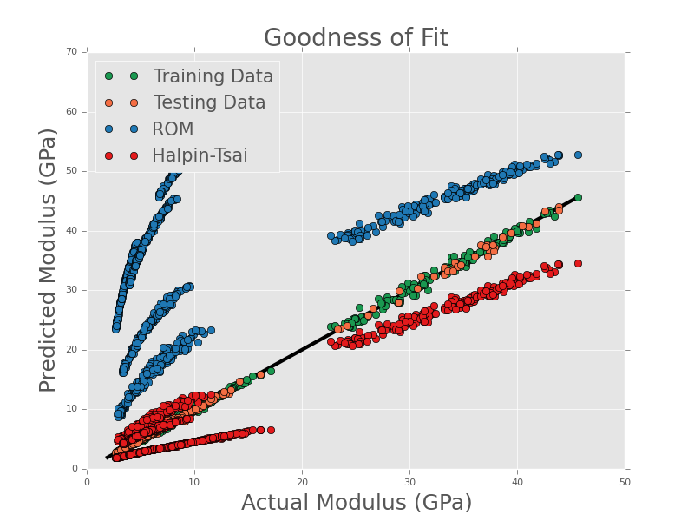

Goodness of fit plot of showing comparison of the new model with standard models for predicting elastic modulus of composite materials. Rule of Mixtures (ROM) and Haplin-Tsai models were applied to the microstructures and the results plotted against the FE results.